1. **Put the docker-compose.yml file and redis.conf file under the project folder**
2. **Change to the project folder where locate the yml and conf files**
3. **Run “docker-compose up -d” to create 6 redis container**

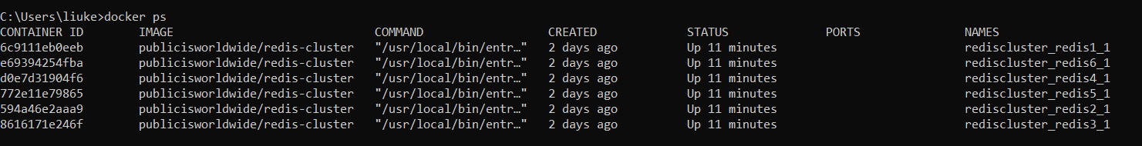

1. **Create Redis cluster**

#docker run --rm -it inem0o/redis-trib create --replicas 1 192.168.42.1:7001 192.168.42.1:7002 192.168.42.1:7003 192.168.42.1:7004 192.168.42.1:7005 192.168.42.1:7006

The ip address is the address set in redis.conf file

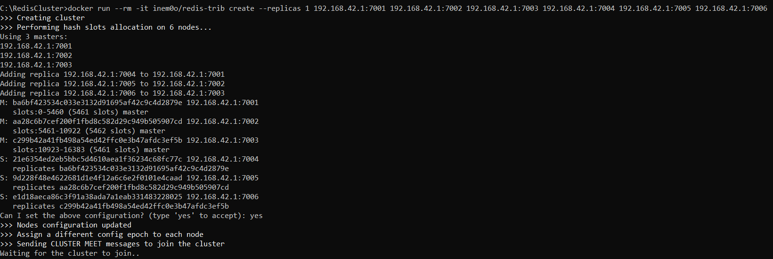

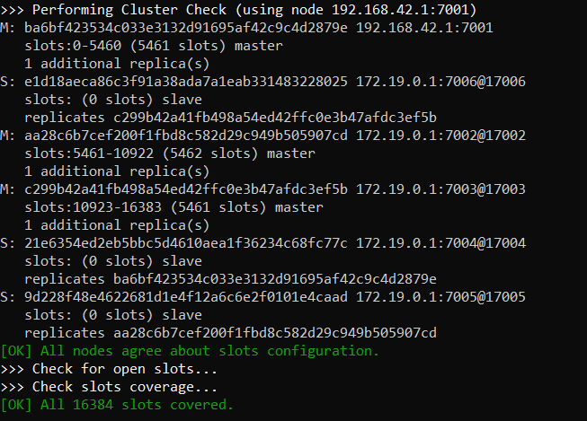

Cluster created successful.

We can see the ports mapping here:

